# Connection

## **Introduction:**

Connection is a system forCollege Forum and Assignment Submission which is useful for online interaction between students and faculty. The System categorizes the courses according to different departments. The System also has Assignment Submission facility which helps in assignment submission and checking. The System caters to the needs of the students as well as the faculty in best possible ways. Assignment Submission is environmentally helpful option for daily clerical assignment submissions. It helps to save paper and thus environment. The students can post assignments online and get it checked. This helps to reduce time and maintaining a record as everything is maintained online. The grading effectively categorizes the assignments and underlines the necessary actions to be taken for the same.

## **Project Constraints:**

* **Login System:** The system will consist of a login system to allow various users to create their profiles. This will also create a secure pathway to protect the user details.
* **Multiple User Roles:** The system will consist of three types of user profiles (admin, teacher, student). The admin will be able to add/remove a teacher or a student from the system. The student will be able upload assignment while the teacher can give assignments via the online system.
* **File Upload System:** The web-application will consist of an upload system which will allow the student and teacher to upload assignments.
* **Recalling Data from Database:** The application will allow users to enter their personal details that will be stored in the database and this data will be later displayed from the database in their respective profiles after login.
* The application will consist of client-side coding using HTML, CSS, JAVASCRIPT (optional) along with a server-side code using PHP. It will be hosted on the universities WEB-DEV server which can be accessed from within the university. Also, GitHub will be used a platform to share and store all the codes.

## **Functional and Non-Functional Requirements:**

### **Functional Requirements**

* ADMIN

1. The admin can create and update profile.
2. Admin can add or remove a teacher or student account from the system.
3. Admin can add or remove a course from the system.

* STUDENT

1. Student can create or update his/her profile.
2. Student Logs in using login credentials and will see main menu consisting of Name information, Personal information and Course information.
3. Student can see the information about the assignment.
4. Student can upload solution of any of his assignments.
5. Student will get a feedback from the teacher about the assignment
6. Student can ask question on the forum

* TEACHER

1. Teacher can create or update his/her profile.
2. Teacher Logs in using login credentials and will see main menu consisting of Name information, Personal information and Course information.
3. Teacher can see the assignments submitted by students
4. Teacher can manually send feedbacks, marks and notes to students.
5. Teacher can answer questions on the forum

### **Non-Functional Requirements**

1. Safety, the system must have the ability to prevent illegal or incorrect operations from teachers or students by using certain tools such as validation control.
2. Understandability, which makes it easy for the students to use and deal with, user friendly by developing good interface and data accessibility, must be easy.
3. Secure and Private.
4. Accessibility, Due to the constraints, the website will be hosted on the RGU server (Q Drive) which reduces the accessibility of the website from places apart from RGU.
5. Performance, the system must be fast

# **E-R DIAGRAM**

ADMIN

STUDENT

TEACHER

ASSIGNMENT

FORUM

Admin_id

S_id

S_name

S_phoneno

course

S_email

A_name

T_dept

T_email

T_name

T_id

T_phoneno

assign_id

assign_date

remark

assign_no

comments

question

likes

question_id

can add /

remove

can add /

remove

can

upload

can

give

can

comment

in

ask

question

in

1

1

M

M

M

M

1

1

M

M

M

M

# **WIREFRAME DIAGRAMS**

* **User Profile Page Layout**

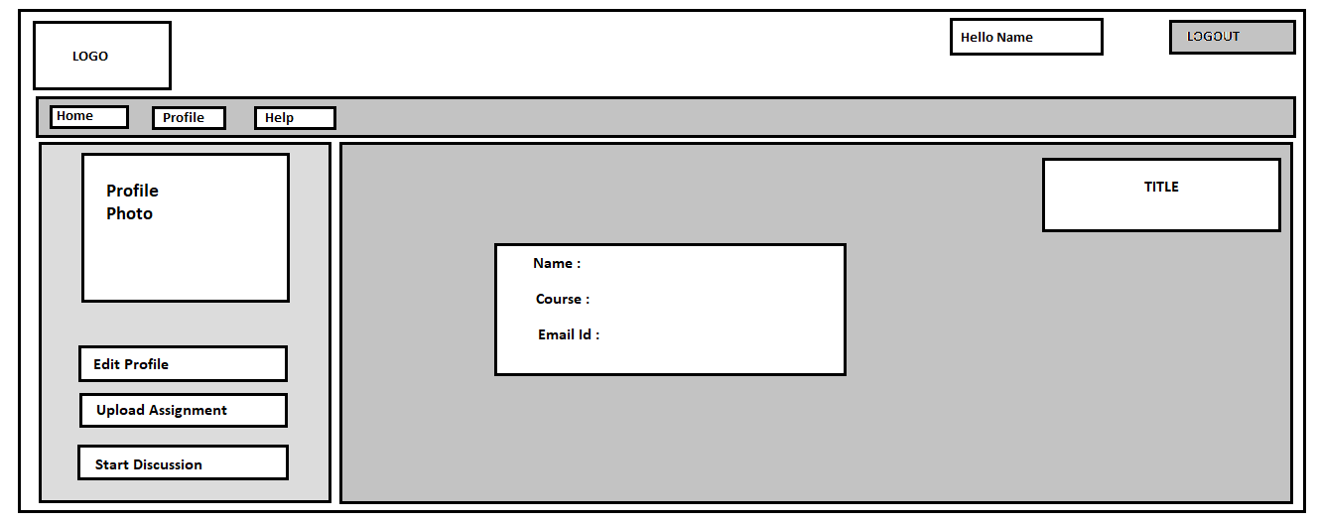

* **Home-Page Layout**

